**IOT BASED SIGNS WITH SMART CONNECTIVITY FOR BETTER ROAD SAFETY**

|  |  |
| --- | --- |
| **Date** | **01-10-2022** |
| **Team ID** | **PNT2022TMID37463** |
| **Project Name** | **Signs with Smart Connectivity for Better Road Safety** |

**ABSTRACT :**

Nowadays,road accident has become a national catastrophe for over populated developing countries. One of the main cause of accident in the sensitive public zones like school, college, hospitals etc. and sharp turning points is the over speed of vehicles avoiding the speed limit indicated in the traffic sign board. Drivers endanger the lives of passengers, pedestrians and fellow drivers not limiting their vehicle speed in these sensitive public zones. The main objective of the proposed system is to operate the vehicles in a safe speed at critical zones minimizing the possible risk of unwitting accidents and casualties. This project paves a system to alert the driver about the speed limits in specific areas and reduce the speed of the vehicles in sensitive public zones without any interference of the drivers. The controls are taken automatically by the use of a wireless local area network. The system operates in such way that the accident information is passed to the vehicles entering the same zone to take diversion to avoid traffic congestion.

**SCOPE OF WORK :**

* The main objective of the proposed system is to operate the vehicles in a safe speed at critical zones minimizing the possible risk of unwitting accidents and casualties.
* Monitoring the speed limit in vehicle.
* Vehicle safety
* Efficiency
* Convenience
* Overall customer experience
* Operational performance

**LITERATURE SURVEY :**

**Assistant Prof. Ankita Gandhi**, Recent studies have shown us that the higher rate of major accidents on road is occurred due to high ungovernable speed rather than speed restricted in the zone and also due to ignorant obstacles. The priority for the driver while driving should be conscious of the particular area so they are aware of the obstacle in front of the road. In most instances, the driver is at fault. . In some of the areas, speed bumps are made to create hindrance to the speed of vehicles, but the drivers do not lower their speeds. Several times due to the driver’s fault speed is not controlled. The whole system is being controlled by an Arduino Uno R3 as a microcontroller.

**Ashok Kumar K, Karunakar Reddy Vanga** ,The major advantage of proposed system is to avoid accidents at rush areas and also provide reliable communication to authorized society in case of emergency. Whenever vehicle enters secured zone, the transmitter of vehicle sends a signal to receiver.

**Vaishnavi Laxmanrao Gadewar**, Several road safety articles and literature databases were searched but very few information was available regarding speed control system. As much till now, not lot of work is carried out in this area. Numerous articles were found related to the present road conditions and urgent need of safety measures. Various studies are being carried out but the documentation is not yet done. Also the implementation of various proposed methods is not feasible.

**Ankita Mishra** , worked on speed control system by the use of RF design. The main purpose is to design the controller for smart display which is meant for the vehicle’s speed control and to monitor the speed zones which have speed limits, and which can operate on an associated embedded system. Smart Display & Control (SDC) can be custom designed so that they can fit into dashboard of the vehicle, and display the information available on the vehicle.

**ARCHITECTURE DESIGN :**

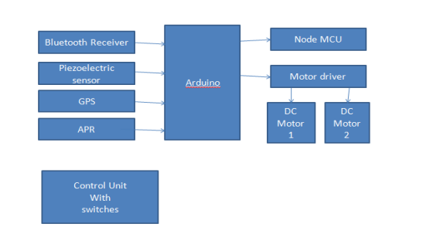

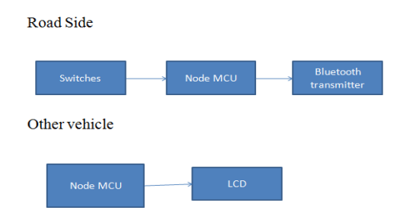**CONCLUSION** :

We have presented a system, to alert the driver about the speed limits in specific areas and reduce the speed of the vehicles in sensitive public zones without any interference of the drivers where controls are taken automatically by the use of a wireless local area network. In the initial phase, we designed the basic block and circuit diagram for the system. In the implementation phase, we executed the hardware with the help of IoT connecting technologies such as Blynk app. Extensive experiments conducted on IoT and other connecting technologies. We can be enhanced this system by implementing camera using Raspberry pi, GSM module in case of network unavailability and low RAM module/zigbee module for long range communication.

**REFERENCE :**

Assistant Prof. Ankita Gandhi, Dhrumil Nanavati, Tushar Mandloi, Gaurav Sagar, Dhruv Sevak Students, Department of Computer Science and Engineering, Parul Institute of Engineering and Technology, Vadodara, India.

Ashok Kumar K, Karunakar Reddy Vanga, International Journal of Recent Technology and Engineering (IJRTE) ISSN: 2277-3878, Volume-8, Issue-1, May 2019.

Rashmi R K, Poonam Avinash Gulwane, Rahul Kudgi, Anaan Shaikh, Vaishnavi Laxmanrao Gadewar,” AUTOMATIC SPEED CONTROL SYSTEM FOR VEHICLES USING COLOR AND HALL SENSORS”, International Research Journal of Engineering and Technology (IRJET) E-ISSN: 2395 - 0056, p-ISSN: 2395-0072, Volume: 04 Issue: 04 | Apr -2017.

“Automatic speed controller for automobile”, International Journal of Trend in Scientific Research and Development (IJTSRD), e-ISSN: 2456-6470, vol. 3, Issue-4 | June 2019.